NBA 6450

Analysis package: anaconda (Python)

Adrian wu (acw82), Todd Edmonds (tse26), Bryan Lu (BL649), Jones Thomas (jnt45)

2016

Problem 1

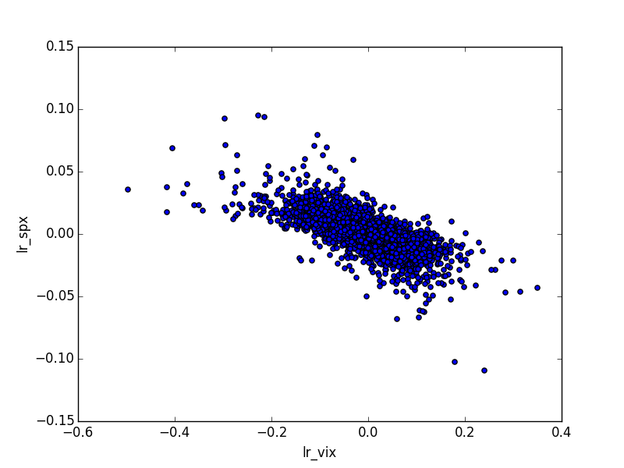

1. S&P500 std dev: 1.1359, VIX std dev: 6.2756, correlation: -0.7132
2. Slope: -0.1291, intercept: -0.0003. It is significant because P-value is 0.
3. Slope = correlation * stddev(y)/stddev(x) -> beta = corr*stddev(S&P500)/stddev(VIX)
4. S&P500 skew: 0.2400, VIX skew: -0.6745. No this is not in line with the market wisdom as seen from 1) the positive skew in S&P500 implies large declines in the stock market are less likely than large stock market rallies; 2) the negative skew in VIX implies large increases in volatility are less likely than large drops in volatility.
5. We see a negative correlation between aggregate stock return and volatility. As seen in the linear regression of S&P500 returns on VIX returns, there is a negative slope between the returns of S&P500 and VIX returns that is statistically significant. This implies an inverse relationship between VIX returns and S&P500 returns.

Problem 2

1. Log Price/Dividend Ratio

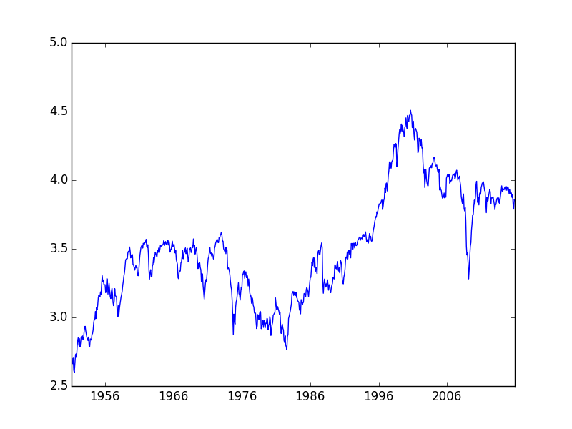

1. Correlation: 0.9000
2. Log P/D Ratio: Persistence: 0.9922, Half Life: 88.5343 months

Log CAPE Ratio: Persistence: 0.9960, Half Life: 173.5174 months

1. Based on the Dickey Fuller Test:

P-value for Log P/D Ratio: 0.2765

P-value for Log CAPE Ratio: 0.4835

Based on the P-values not < 0.05, it is not econometrically sound to use the P/D ratio or CAPE ratio in regressions.

Problem 3

1. Default Spread Statistics:

Mean: 1.1028

Standard Deviation: 0.4702

Persistence: 0.9633

Half Life: 18.5419 months

1. Term Spread Statistics:

Mean: 1.7857

Standard Deviation: 1.2824

Persistence: 0.9524

Half Life: 14.2232 months

1. ICC statistics:

Mean: 7.4448

Standard Deviation: 2.6913

Persistence: 0.9486

Half Life: 13.1425

1 month

|  |  |  |  |  |  |
| --- | --- | --- | --- | --- | --- |
|  | P/D Ratio | CAPE Ratio | Default Spread | Term Spread | ICC |
| slope | 0.0012 | -0.0029 | 0.0096 | 0.0004 | 0.0058 |
| $$R^{2}$$ | 0.0001 | 0.0007 | 0.0000 | 0.0001 | 0.0013 |
| T-Stats | 0.30 | -0.69 | -0.07 | 0.19 | 1.52 |

3 months

|  |  |  |  |  |  |
| --- | --- | --- | --- | --- | --- |
|  | P/D Ratio | CAPE Ratio | Default Spread | Term Spread | ICC |
| slope | 0.0038 | 0.0022 | 0.0199 | -0.0011 | 0.0038 |
| $$R^{2}$$ | 0.0004 | 0.0001 | 0.013 | 0.0003 | 0.0158 |
| T-Stats | 0.43 | 0.24 | -1.07 | -0.3 | 1.88 |

1 year

|  |  |  |  |  |  |
| --- | --- | --- | --- | --- | --- |
|  | P/D Ratio | CAPE Ratio | Default Spread | Term Spread | ICC |
| slope | 0.015 | 0.03 | -0.1231 | -0.0236 | 0.0160 |
| $$R^{2}$$ | 0.034 | 0.0063 | 0.1232 | 0.0337 | 0.0681 |
| T-Stats | -3.38 | 1.6 | -3.79 | -3.28 | 3.59 |

3 years

|  |  |  |  |  |  |
| --- | --- | --- | --- | --- | --- |
|  | P/D Ratio | CAPE Ratio | Default Spread | Term Spread | ICC |
| slope | -0.0248 | 0.0722 | -0.1216 | -0.073 | 0.0159 |
| $$R^{2}$$ | 0.0017 | 0.0133 | 0.0451 | 0.121 | 0.0251 |
| T-Stats | -0.72 | 2.28 | -2.84 | -5.89 | 2.11 |

5 years

|  |  |  |  |  |  |
| --- | --- | --- | --- | --- | --- |
|  | P/D Ratio | CAPE Ratio | Default Spread | Term Spread | ICC |
| slope | 0.054 | 0.1361 | -0.0954 | -0.0758 | -0.0148 |
| $$R^{2}$$ | 0.00 | 0.0286 | 0.0167 | 0.0784 | 0.0139 |
| T-Stats | 0.12 | 3.29 | -1.92 | -5.28 | -1.66 |



1 month

|  |  |  |  |  |
| --- | --- | --- | --- | --- |
|  | P/D Ratio and ICC | CAPE Ratio and ICC | Default Spread and ICC | Term Spread and ICC |
| Slope ICC | -0.0013 | 0.0012 | 0.0015 | 0.0015 |
| Slope (other) | -0.0002 | -0.0034 | 0.0009 | 0.0003 |
| $$R^{2}$$ | 0.001 | 0.002 | 0.003 | 0.003 |
| T-Stats (ICC) | -0.673 | 0.784 | 0.11 | 0.966 |
| T-Stats (Other) | 1.48 | 0.272 | -0.913 | 0.587 |

3 months

|  |  |  |  |  |
| --- | --- | --- | --- | --- |
|  | P/D Ratio and ICC | CAPE Ratio and ICC | Default Spread and ICC | Term Spread and ICC |
| Slope ICC | 0.0038 | 0.0038 | 0.0035 | 0.0042 |
| Slope (other) | -0.0004 | -0.0015 | -0.0172 | -0.0016 |
| $$R^{2}$$ | 0.011 | 0.011 | 0.023 | 0.014 |
| T-Stats (ICC) | -1.084 | 0.553 | -1.2 | 1.746 |
| T-Stats (Other) | 2.539 | 1.618 | -3.121 | 2.137 |

1 year

|  |  |  |  |  |
| --- | --- | --- | --- | --- |
|  | P/D Ratio and ICC | CAPE Ratio and ICC | Default Spread and ICC | Term Spread and ICC |
| Slope ICC | 0.016 | 0.0161 | 0.0121 | 0.0165 |
| Slope (other) | 0.0044 | 0.0099 | -0.1149 | -0.0241 |
| $$R^{2}$$ | 0.064 | 0.065 | 0.167 | 0.099 |
| T-Stats (ICC) | 0.242 | 4.541 | 1.107 | 6.05 |
| T-Stats (Other) | 9.153 | 5.248 | -8.53 | 3.007 |

3 years

|  |  |  |  |  |
| --- | --- | --- | --- | --- |
|  | P/D Ratio and ICC | CAPE Ratio and ICC | Default Spread and ICC | Term Spread and ICC |
| Slope ICC | 0.0152 | 0.016 | 0.0094 | 0.0138 |
| Slope (other) | -0.0481 | 0.0093 | -0.111 | -0.0738 |
| $$R^{2}$$ | 0.027 | 0.021 | 0.049 | 0.136 |
| T-Stats (ICC) | 2.834 | 2.878 | 4.166 | 4.683 |
| T-Stats (Other) | 2.737 | 9.003 | -1.18 | -5.97 |

5 years

|  |  |  |  |  |
| --- | --- | --- | --- | --- |
|  | P/D Ratio and ICC | CAPE Ratio and ICC | Default Spread and ICC | Term Spread and ICC |
| Slope ICC | -0.0164 | -0.0151 | -0.0271 | -0.021 |
| Slope (other) | -0.1040 | -0.0227 | -0.1552 | -0.0773 |
| $$R^{2}$$ | 0.027 | 0.01 | 0.068 | 0.11 |
| T-Stats (ICC) | -2.833 | -6.836 | -1.716 | 1.273 |
| T-Stats (Other) | 5.882 | 13.762 | -4.365 | 0.29 |

Term Spread and ICC works best for a 3 years window based on its relatively higher R^2 and higher T-Stat